Uterine tube

Synonyms
Fallopian tube and salphinx (meaning tubes)

Length
7 to 14 cm

Parts
- Infundibulum
- Ampulla
- Isthmus
- Intramural part
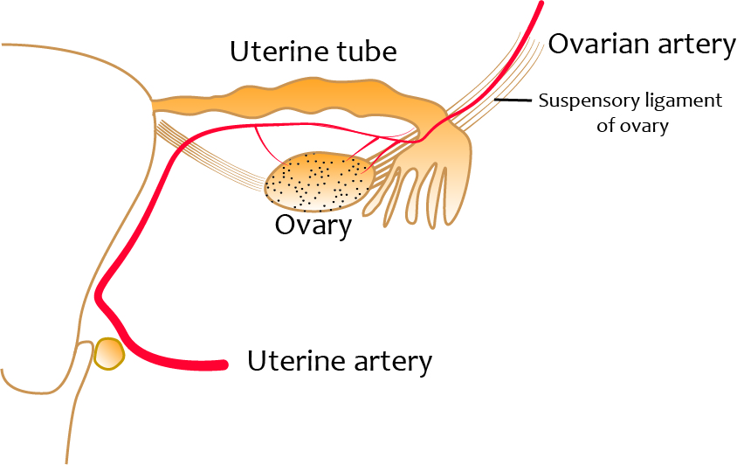

Arterial supply

Two sources
- Uterine artery
- Ovarian artery - supplies ovarian end of the uterine tube

Veins
Run along the arteries

Lymphatics
Drain into the preaortic and aortic lymph nodes

Innervation
Autonomic supply - ovarian and inferior hypogastric plexuses
Pain sensation - relayed in T11, T12, L1, and L2 segments

Clinical importance - tubal pregnancy
Implantation of the conceptus in the uterine tube - tubal pregnancy
Most commonly attaches to the ampulla part
More prone to rupture
Ruptured ectopic - must be considered in all acute abdomen cases among females

Clinical importance – tubectomy
Permanent method of contraception in women
A Falope ring is placed in the isthmic region of the uterine tube

